SPARK Data Processing
- Data Loading and Basic Inspection:
  - Load the bank.csv dataset into a Spark DataFrame.
  - Perform basic data inspection tasks such as showing the first few rows, printing the schema, and displaying a summary of numerical columns.
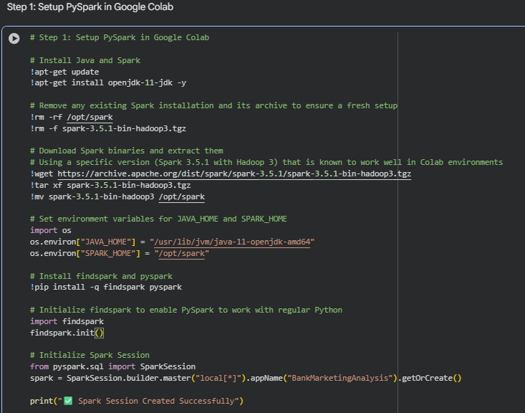
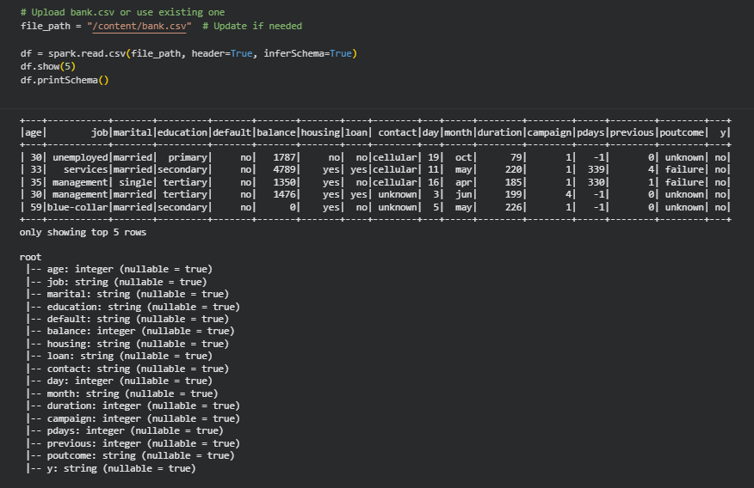
- Data Filtering and Column Operations:
  - Filter the dataset to include only clients with a balance greater than a certain threshold (e.g., 1000).
  - Extract the month from the 'month' column and create a new column for the quarter of the year.
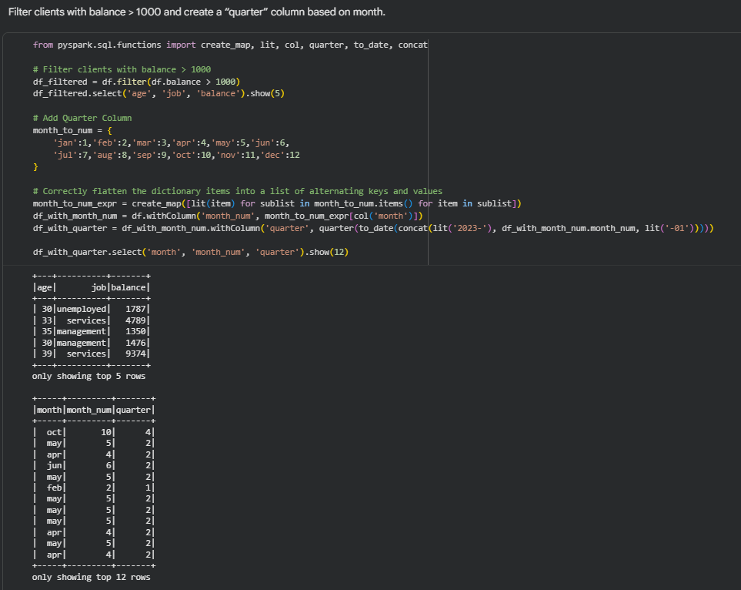

- GroupBy and Aggregation:
  - Group the data by job type and calculate the average balance and median age for each job category.
  - Find the total number of clients for each marital status who have subscribed to a term deposit.
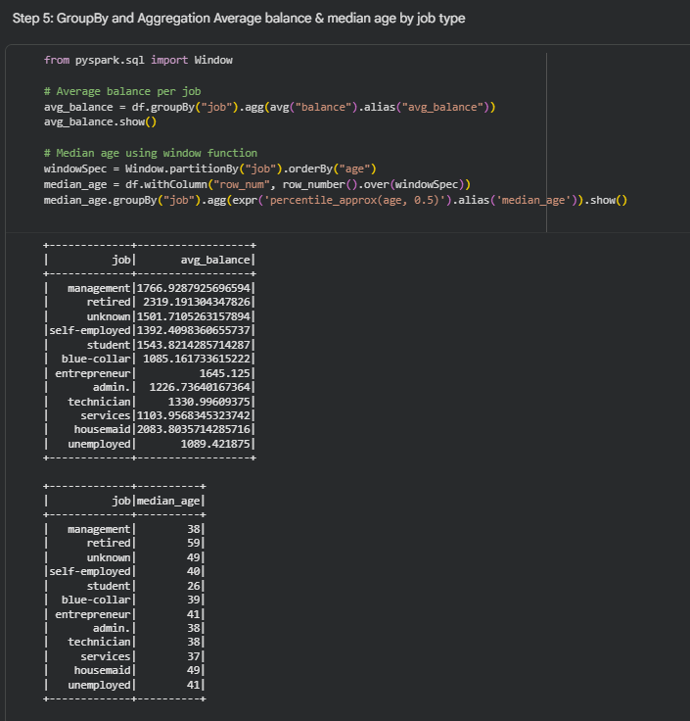
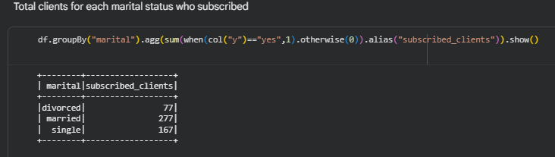
- Use UDF to Categorize Age Groups:
  - Write a UDF that categorizes clients into age groups ('<30', '30-60', '>60') and apply it to create a new column age_group.
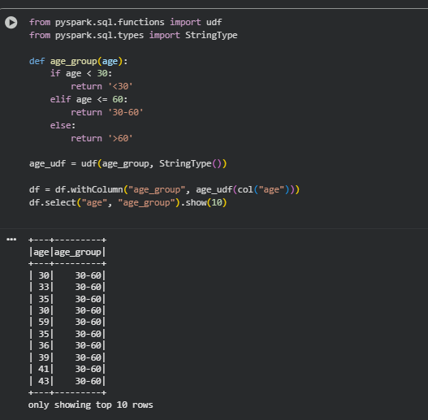
- Advanced Data Transformations:
  - Calculate the subscription rate (percentage of clients who subscribed to a term deposit) for each education level.
  - Identify the top 3 professions that have the highest loan default rate.
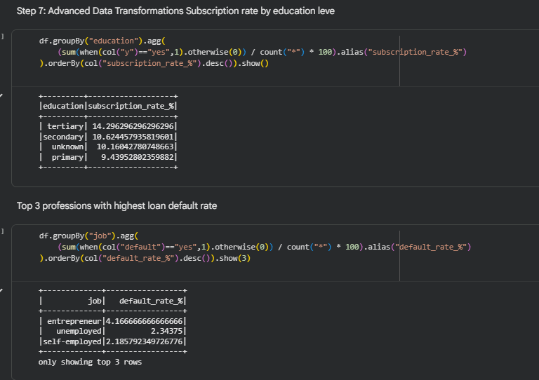
- String Manipulation and Date Functions:
  - Concatenate the 'job' and 'marital' columns into a new column 'job_marital'.
  - Use string functions to convert the 'contact' column to uppercase.
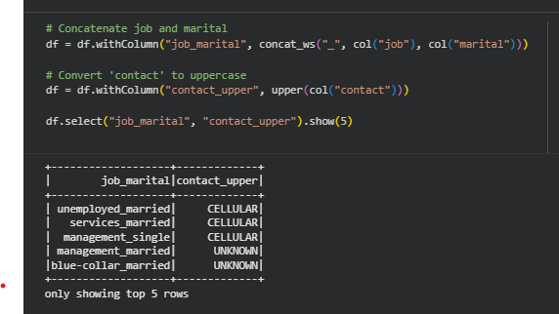
- Data Visualization
  - Convert the Spark DataFrame to a Pandas DataFrame.
  - Create a bar plot showing the count of clients by job type.
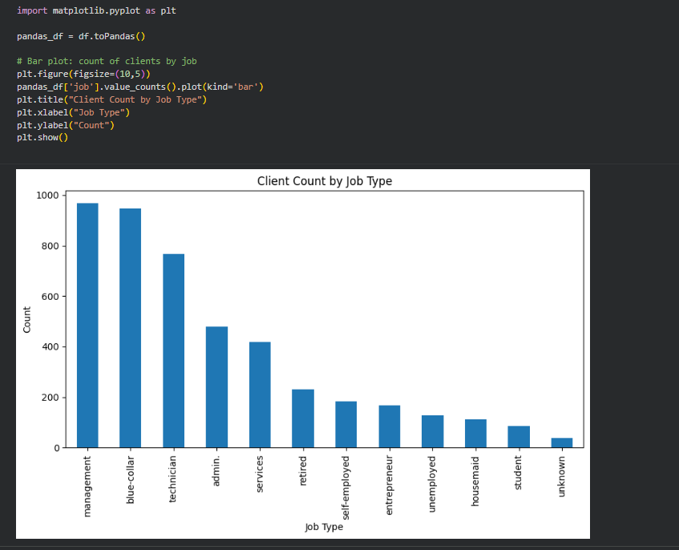
- Complex Queries for Insights:
  - Analyze which month of the year has the highest number of clients contacted, and determine the success rate of the campaign in that month.
  - Find the average duration of contact for clients who subscribed versus those who did not.
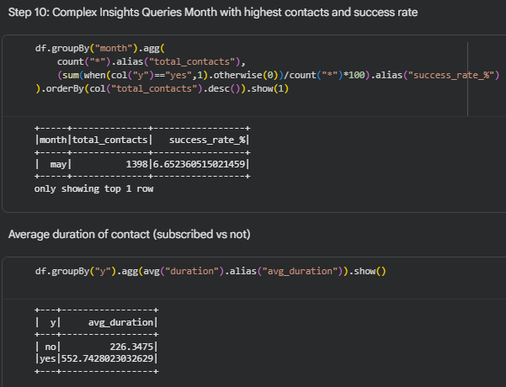
- Correlation Between Age and Balance:
  - Calculate the correlation coefficient between 'age' and 'balance' to see if there’s any linear relationship between these two variables.
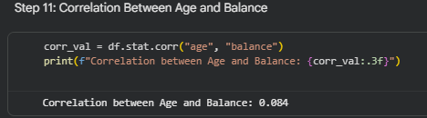
- Exploring Loan Defaults:
  - Analyze the proportion of clients with and without a credit default and visualize the count of defaulters and non-defaulters.
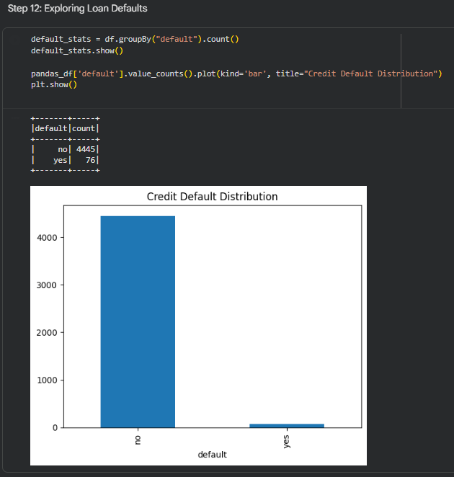
- Contact Method Analysis:
  - Investigate which contact method ('cellular', 'telephone', etc.) has the highest success rate for term deposit subscriptions.
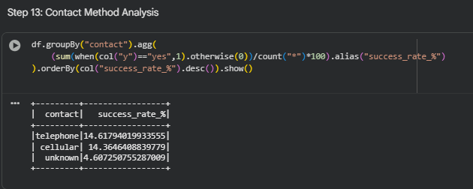
- Data Processing with Spark SQL:
- Calculate the average account balance for different age groups or the most common job types. (Use CREATE TEMPORARY VIEW in Spark SQL to query data using SQL syntax.)
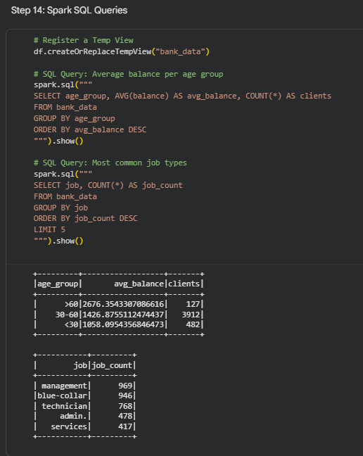
Submission Guidelines:
- You have the flexibility to perform the Spark data analysis either in Google Colab or in your local environment. Choose the option that is most convenient for you.
- If you choose to work in a local environment, please ensure you take screenshots of both the code and the output for each question. Make a copy of this doc file and include the screenshots in your copied document.
- If you opt for Google Colab, ensure to include the Colab file directly as part of your submission.
- Once your project is complete and your documentation is ready, please upload the document along with any other required files to the submission dashboard.

